Subgraphs Continued
*All image designations correspond to their sections only

Introduction

Remember subgraphs from earlier in the class? We learned about how we can create a subset of the graph by defining a subset as G’={V’, E’}, with G’ being a subset of the graph G. Returning to this concept, we will explore how defining subsets can be important for studying the features of a graph. Subsets are particularly important in detecting groups, or clusters of nodes that are more inter-related to each other than they are to other parts of the graph (Newman and Girvan 2004).

Graph Connectivity

One of the key questions in looking at a subgraph is if the subgraph is connected or not. Subgraphs can be defined as any selection of nodes and edges, it is purely a mathematical concept, composed of whatever elements that you decide to include in the subgraph.

- Connected Subgraph (b) Disconnected Subgraph
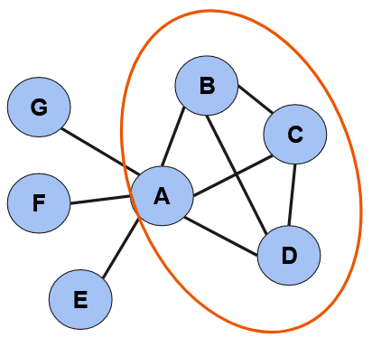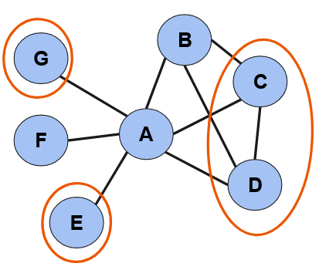

Subgraphs are either connected or disconnected, as shown in image (a) and (b). If all nodes in the graph can reach each one another through some path of edges, then the graph is connected. If every node in the subgraph cannot reach every other node through some path, then the subgraph is disconnected.

Similarly, graphs can either be connected or disconnected. Imagine that the below image (c) is a graph. Notice how it is disconnected. You can see that nodes on each side of the graph are unable to reach one another. Each of these two different sides of the graph form a separate component. A component is a connected subgraph where no additional nodes can be reached through some finite pathlength from any of the other nodes in the subgraph. In essence, a component is a subset consisting of all the nodes that can reach one another through a finite pathlength. Unlike a normal subset, a component is determined by the connectivity of nodes, as opposed to simply being chosen by the definer.

(c) Graph with two components
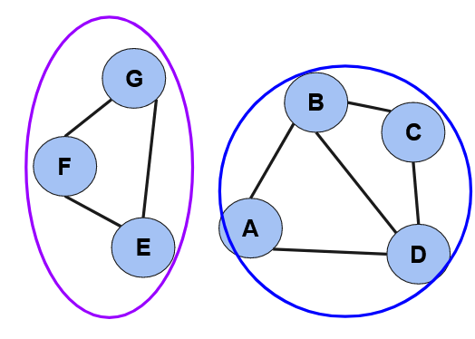

A graph may have as many components as it happens to have, there is no limit. However, we are often interested in one component in particular, call the giant component. A giant component is the component in the graph with the largest number of nodes. Most of the time it is also the component with the largest number of edges, but the two do not have to coincide technically. Below in image (d), the giant component is the component V’= {$V_{A}$,$V_{B}$, $V_{C}$, $V_{D}$, $V_{E}$, $V_{F}$, $V_{G}$, $V_{H}$,$V_{I}$, $V_{J}$}.

(d) Graph with three components
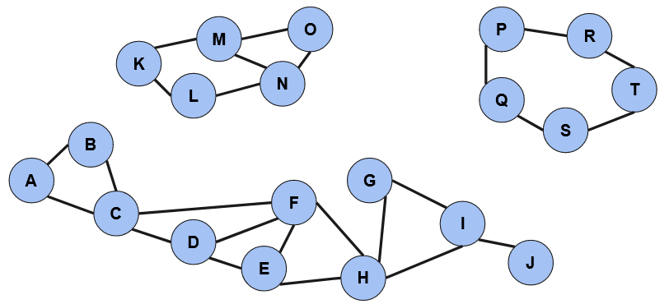

The diameter of the graph is the longest shortest path in the giant component. In the above graph, the diameter is 5 (AC, CF, FH, HI, IJ). Thus, of all the shortest paths between any nodes in the subgraph, we choose the longest of all those shortest paths as the diameter. In a graph of only one component, the diameter is just the longest shortest path in the graph. Diameter serves as a measure of how long in path terms the two nodes that are furthest apart from one another are. Imagine you have two graphs with the same number of nodes and edges, but one graph has a low diameter and the other has a very large diameter. The one with the larger diameter is likely to have a lower/longer transmission of information across the network, as the network would be more like a long chain, rather than a series of interconnected groups (like in small world networks below).

What is a Group?

Groups are pretty vital to social life. You are likely a member of a college club, of a local religious organization, a political party. If you are reading this as part of a course, you are likely the member of a college or university, which is itself a group of people who study within the same organization. Groups are everywhere, and you are likely a member of quite a few!

A group of people, in the most basic social network terms, is a set of people who are connected. However, it only gets more difficult to define a group from there! You are likely unconnected to a lot of people who might be a part of the same group as you. It is unlikely you know everyone in your college, but still there are aspects of groupness because you belong to the same network. It’s not easy to know where a group begins and ends as a theoretic matter, and it is just as hard as a methodological matter.

Newman and Girvan (2004) argue that a group is a set of nodes who more interconnected with one another than you would expect by chance. The idea of chance is a powerful logic in science, because if nodes associate with each other in a way that seems random, then perhaps there is no social (or chemical/physical/biological/etc.) principle organizing the network. Thus, when nodes associate with each other more than we would expect by chance, they are demonstrating some type of social logic that makes them associate with certain nodes over others. Thus, we might understand this non-random network clustering as nodes organizing themselves into groups, either intentionally or not.

We present several methods for detecting groups. First are cliques and n-cliques, which looks at the amount of connectivity between nodes. Such a method is generated from local connectivity. Afterwards, edge and node cutset strategies are introduced, which look at the whole graph and then edges or nodes are selectively eliminated to partition the graph into constituent groups.

Clique

If we are interested in a group, we might ask what is the “most group” a subgraph can be? A group can’t be any more connected than if everybody in the group has a network tie with everyone else in the group.

We call a subgraph of nodes where every node is adjacent to every other node a clique. A clique is technically a maximally connected subgraph, also known as a complete subgraph. It’s maximally complete because we can’t add any additional edges between nodes.

A clique is known by its size, or how many nodes are in the subgraph. Thus, a subgraph of five nodes that are maximally connected are a clique of size 5. A complete subgraph of four nodes is a clique of size 4. Notice, that a clique of size 3 is something we’ve already talked about as something special. A clique of size 3 is a complete triad!

A Clique of Size 4
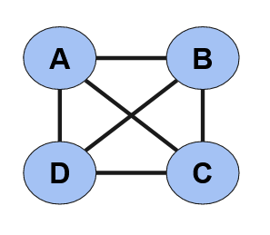
n-Clique

While cliques might identify a group by if every node is connected to every other node, how might we measure groups where everyone is not connected directly with every other node? For example, if you are in a big group like a club with 50 members, you might not actually know everyone in the group. Given how hard it is to meet the definition of a clique, there is a concept called an n-clique which identifies a group as the set of members who can reach one another through a minimum path length of n.

- A 2-clique (b) A 2-clique (c) A 3-clique
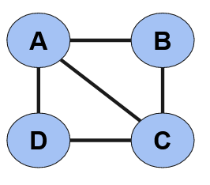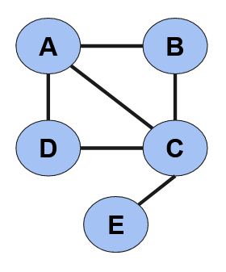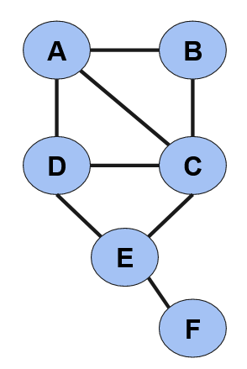
Notice above the three subgraphs. In subgraph (a), every node is able to reach every other node through a pathlength of 2. The idea also seems to conform to our idea of what a group might look like, as D and B are connected to both A and C, although not to each other. Additionally, A and C are connected, so this indicates a certain amount of redundancy in the network ties. However, subgraph (b) is also a 2-clique. Any node, even node E, can reach any other node in the network through a pathlength of 2. It does not quite seem to meet our intuitive expectations of a group in quite the same way as subgraph (a) however. This is because node E is non-redundantly connected only through node C. Still however, subgraph (b) meets the definition of being a 2-clique.

Subgraph (c) meets the definition of a 3-clique, because any node can reach any other node in the subgraph through a pathlength of 3. Notice how as the pathlength n increases, the less the n-clique begins to intuitively make sense as a group. Thus, while the concept on an n-clique is useful for some purposes, the larger the path length n becomes, the less accurately the concept may be measuring meaningful network clustering.

Edge Removal
If we are interested in starting with the whole graph and then dividing the graph into groups, we can either do so by removing edges or by removing nodes. Removing edges is a logical option if we think that it methodologically makes sense that the connection is likely to be the demarcating feature of groups. For example, edge removal is quite logical in a network of chemical bonds between atoms. It is not the atom which disappears when the material breaks, but the chemical bond. Thus, it makes sense to detect groups in a material through edge removal, and physicists are often interested in edges for this reason.

The question then becomes which edges to remove. The first concept is what is called an edge cutset. A cutset is a procedure whereby we identify the fewest number of edges that we can remove in a graph to disconnect the graph into components. For example, in the following image, the edge cutset of the graph is 2, edge CF and edge DE. By removing these edges, there would be four nodes at the top, and a closed triad at the bottom of the graph.

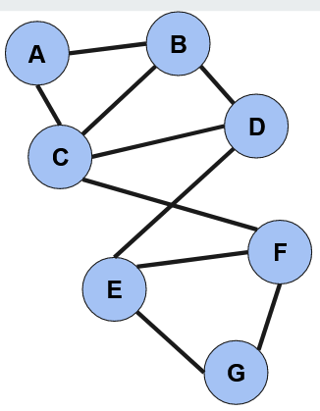
Note here that the goal is to separate the graph into another set of components by removing the fewest numbers of edges each time to do so. In more complicated graphs, one can repeat this procedure as many times as desired. Imagine a graph with thousands of nodes. One can continue to find the edge cutset to continuously divide the graph into its constituent groups. There are procedures about when it may be best to stop removing edges, but that is beyond this chapter.

Another idea about removing edges is called a U-V cutset. In a U-V cutset, two specific nodes are identified, and then edges are removed so that the nodes are separated into separate components. For example, in the above graph, to separate nodes D and B as a UV-cutset, edges BD, BC, AC or BD, CD, CF would need to be removed to separate B and D into separate components. Although perhaps less generalizable than an edge cutset procedure, a U-V cutset can be useful for determining what previously existing ties may have broken to cause the fragmentation of a graph.

Node Removal

Likewise, there is a strategy whereby one can divide a graph by removing nodes. This might make sense when an individual could be removed from a network, or if individuals are thought to be key connectors in the case of cohesive blocking in the next section. As compared to those who research material sciences, sociologists are very interested in node removal techniques. Sociologists are interested in all techniques so long as the technique better matches the logic of the research question.

The main concept in node removal group detection techniques is the idea of k-connectedness. A graph is k-connected if it can be disconnected into two or more components through the removal of k nodes. Thus, the subsequent graph is k-connected with a k of 1, also known as being 1-connected.

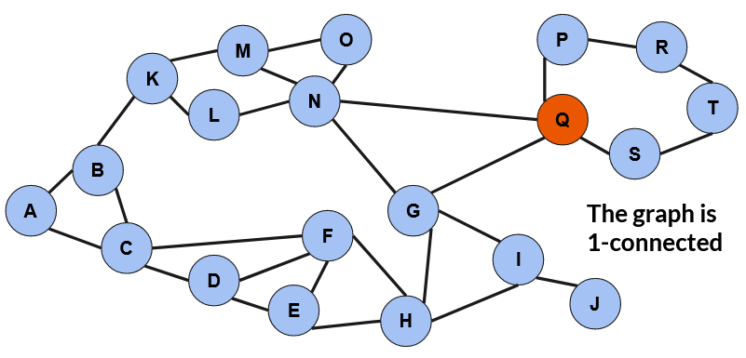

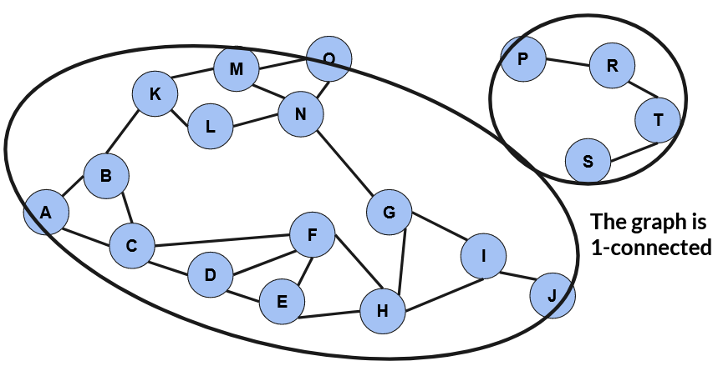

By removing the node Q, the graph is separated into two components, as indicated by the circles. Through this process of removing nodes as parsimoniously as possible in order to disconnect the graph, we can detect the groups that would form if there is a fragmentation of the network. Likewise, we might interpret the groups as the underlying groups that combine to form the larger network. Interpreting the groups is as much a theoretical question as it is a technical question.

Cohesive Blocking

The idea of belonging to a group is of core sociological interest, but there are two ways in which people can be conceived as belonging to a group. The first way is about identification. One can identify or be identified with being a member of a larger group as a matter of nomination. One might identify as a member of a political party for example. However, despite professed group membership, they may have few social connections with other members of the group. The second method of group membership is based on the pattern of social relationships one has with other members of the group. Thus, while the first is professed identification based group membership, the second is a relational form of group membership.

This was the core insight that motivated work by Moody and White (2003) on detecting structural cohesion. Structural cohesion is defined as the social solidarity that derives from one’s position in the network of social relations. It asks how we can understand the influence nodes have on the behavior of others as a function of their network location.

To study this question, Moody and White proposed a technique called cohesive blocking, which uses a networks k-connectedness to repeatedly break apart a network into its constituent group clusters. The node(s) which most easily break apart the network are “removed” first, becoming the boundary between the resulting groups. Then each resulting group is treated in the same manner, where the k-connectedness is assessed and the k nodes form the boundaries of smaller groups.

- A graph (b) First Iteration (c) Second Iteration
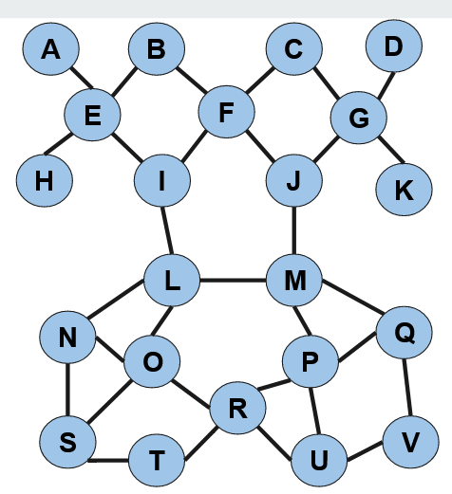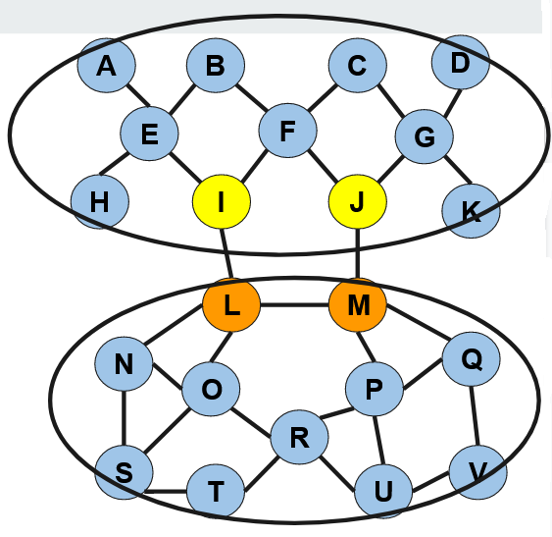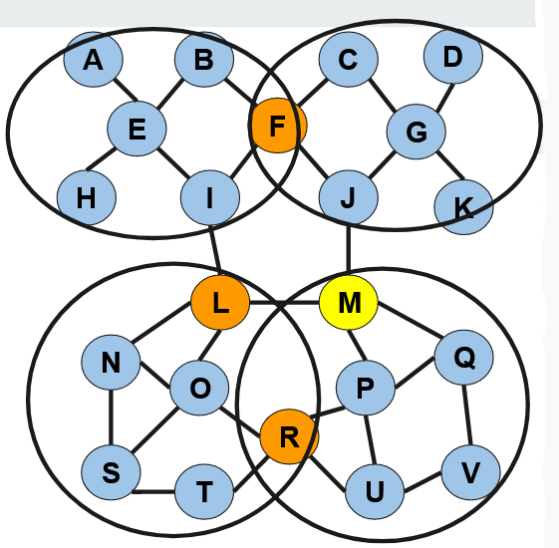
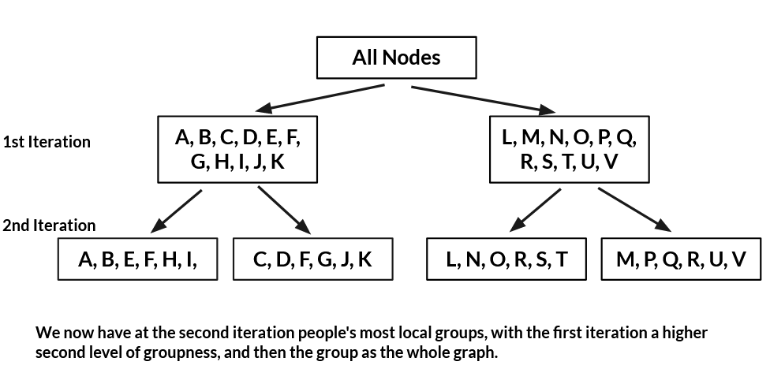

As can be seen in the above image, there is a graph (a). If we would like to find the k-connectedness of this graph, we see that some combination of I, J, L, and M would be removed. Only two of these four nodes would need to be removed however. I and J would separate the top group, while L and M would separate a bottom group. However, both have more connections with one group than the other. In this case, I and J would be included in the top group, while L and M would be included in the bottom group due to their additional connections with the members of these groups. When two nodes could be cut, leading to the same graph partition, each node is assigned to the group which is shares more ties with.

The cohesive blocking continues onto the next level. Notice that the top group is 1-connected, as with the removal of node F, the group breaks into two components. Thus, F will belong to both groups, but there are two separately identifiable groups. The bottom group will also break into two groups, although it is 2-connected. Nodes R and either L or M must be removed to disconnect the graph. Thus, L and M are assigned to different groups, while node R belongs to both groups. One can continue the process until the graph can no longer be broken into components.
In doing this, you have divided the original graph into different iterations, or levels at which groups are more or less cohesive. While in the first iteration a group may appear different from the other group formed in that iteration, even that group can be divided into its own clusters of members. You thus form varying degrees of social connectedness, which can relate to social outcomes.

For example, Moody and White find that the more a student has a socially cohesive position in their school (7-12th grade) network, the more likely they are to like their school. Position as determined by other measures of network position alone do not completely predict affinity towards one’s school, but actually belonging to a group, that is connected to other groups, and so on, predicts satisfaction. This makes sense if we consider how being part of a social group, being a member of a socially cohesive organization, often contributes to people’s life satisfaction.

Menger’s Theorem

Menger’s Theorem is a unique mathematical artifact of graph connectivity. Menger’s Theorem states that, for a k-connected graph, there are k independent paths between any two non-adjacent nodes in a graph. While this may be a bit confusing at first, looking at an example will help illustrate the point.

Note that this idea is a theorem, meaning that no one has mathematically proven it yet, only that no one has found a counter example. The phenomenon stems from the fact that even trying to change the network a little bit can mean that the k-connectivity of the graph changes with it. Thus, even a seemingly minor change at the edge of the graph can lower or increase the k-connectivity, and the number of independent paths between any two non-adjacent nodes.
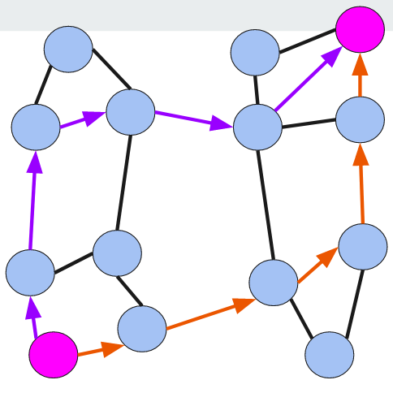
Notice that between the two pink nodes, that there are two completely independent paths (purple and orange paths) that connect the two nodes. The graph is 2-connected, meaning it would take the removal of two nodes to disconnect into components. As such, we should be able to identify at least two completely independent paths from any one node to any other non-adjacent node. Knowing that the orange and purple edges are the same as any other edge, you can pick any two non-adjacent nodes and find two independent paths between them!

Small World Networks

One of the primary concerns of network analysis is the transmission of something through a network. It could be gossip, advice, knowledge, communicable disease, cultural styles, or new innovations. If there is some sort of content that can get spread through a network of adjacent nodes, social network analysis can provide insights into how that spread occurs.

A major insight into the rapid spread of such content (let us just say information), came with the discovery of small world networks. Information spreads more rapidly when the average path length between any two nodes in the network is low. A longer average path length means that it takes longer for information to spread from any one random node to another. Thus, network structures with low average path lengths are more conducive to the diffusion of knowledge.

If you wanted to design a social network with the shortest possible path between nodes, then you would make your network a clique, so that everyone could directly contact everyone else. However, that is an unrealistic amount of connectivity. Likewise, you could develop a graph where everyone is connected to a central node, who can then connect everyone together in what is called a hub-and-spoke model. However, this is also unrealistic as people generally have connections with more than one person and people can rarely connect with so many people (see Dunbar).

If you assume every node has the same number of connections, a really good method of creating a short average path length would be for everyone in the network to randomly know one another. Randomly choosing connections is a pretty easy way of creating a short average path length. However, it is also not quite all that likely, as we tend to prefer making connections to those who share connections with us (due to ideas such as G-transitivity and triadic closure).

Small world networks grapple with this problem of how to lower the average shortest path length while understanding the tendency for connections to cluster. Watts and Strogatz (1998) found that just a small amount of random tie formations in a network drastically reduces the average path length, while only decreasing clustering a very small amount. Thus, the unique network topology of a small world graph allows for high levels of clustering and low average path lengths, meaning that information can transfer through networks very rapidly. Thus, small world networks are defined by high clustering and low average path length that results from bridging ties between clusters. The advantage of such a network form is the relatively rapid transmission of information, even compared to a perfectly random network.

This can be seen in the following image. Each circle has a different color depending on its size. However, rather than representing a node in this case, the circles represent how many nodes are in a cluster. Thus, the bigger the circle, the larger the cluster of nodes represented by that circle. Imagining someone’s hometown, or neighborhood, you might think about how they might be more likely to interact with someone from their hometown. Going to the same coffee shop, the same high school, one is more likely to create connections within the community that they live. Likewise, they are likely to make friends with friends of their friends, who are more likely to come from the same area. Given these tendencies in the formation of social ties, it is understandable that networks have a tendency to cluster together.

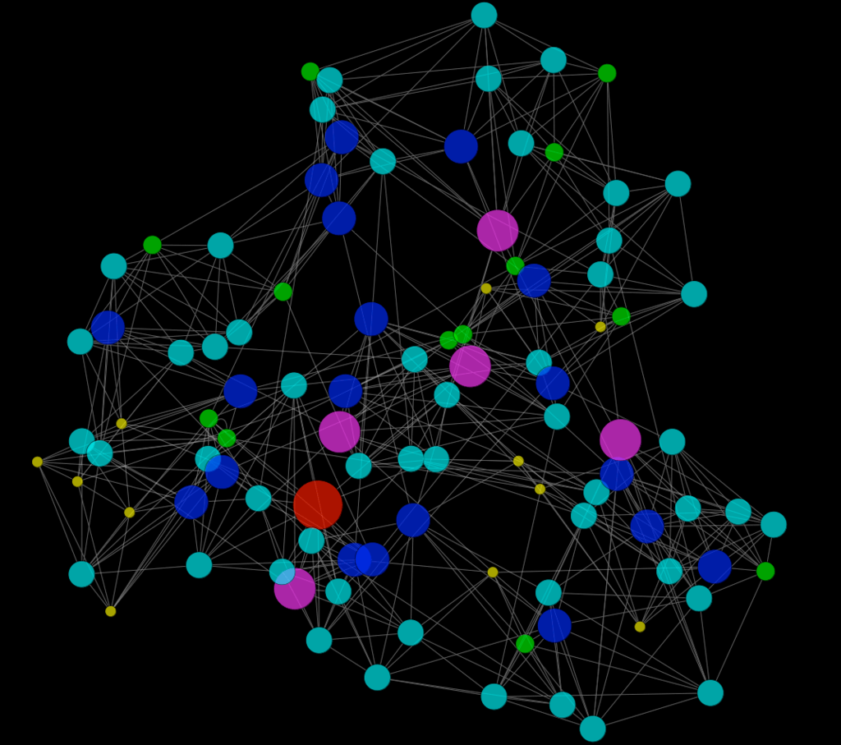

The key to reducing the distance between these clusters is the bridging ties that connect the clusters. Bridging ties are connections that link parts of the network that would otherwise be disconnected. Imagine if someone in town had a friend the next town over, maybe from work. Any information that is generated in their cluster could be easily shared with their work friend, and continue to pass into the friend’s cluster. Thus, bridging ties between clusters significantly reduce the average shortest path length in a graph, leading to the rapid transmission of information.

As this is how human communities tend to organize themselves, we live in a network structure with a fortuitous balance of clustering and diffusion. However, what is a positive regarding information flow, is a less ideal when it comes to something that we do not want to diffuse across the network. Communicable disease is one such thing that can travel from person to person within a network. One strategy of epidemiologists is to, by understanding how to make interventions in the network structure, attempt to contain or slow the spread of disease.

Perhaps you have ever heard of 6-degrees of separation, about how we are never really all that socially far away from someone else? The insights of 6-degrees of separation are fundamentally about this clustering of local networks and the bridges that connect the clusters. Stanley Milgram ran an experiment where he asked people in Omaha to send a package to someone they had never met in Boston. They were supposed to forward the package on to someone that they knew and who they thought could get it to someone they knew, and so on, until it reached its target destination in Boston.

If you were asked to do the same, you might send it to someone you happened to know in Boston. Or if you did not know anyone, perhaps someone you thought might know someone in Boston, or perhaps New York, as they are likely to know someone in Boston. When we search our networks in a targeted manner, you can find how in a reasonably small path length you can connect to a tremendous number of people, because once you use bridging ties to get to a cluster, someone within that cluster can direct you to a co-member of the cluster.

